**Class Participation Bonus 1**

**Student Name: ARNAV KUCHERIYA**

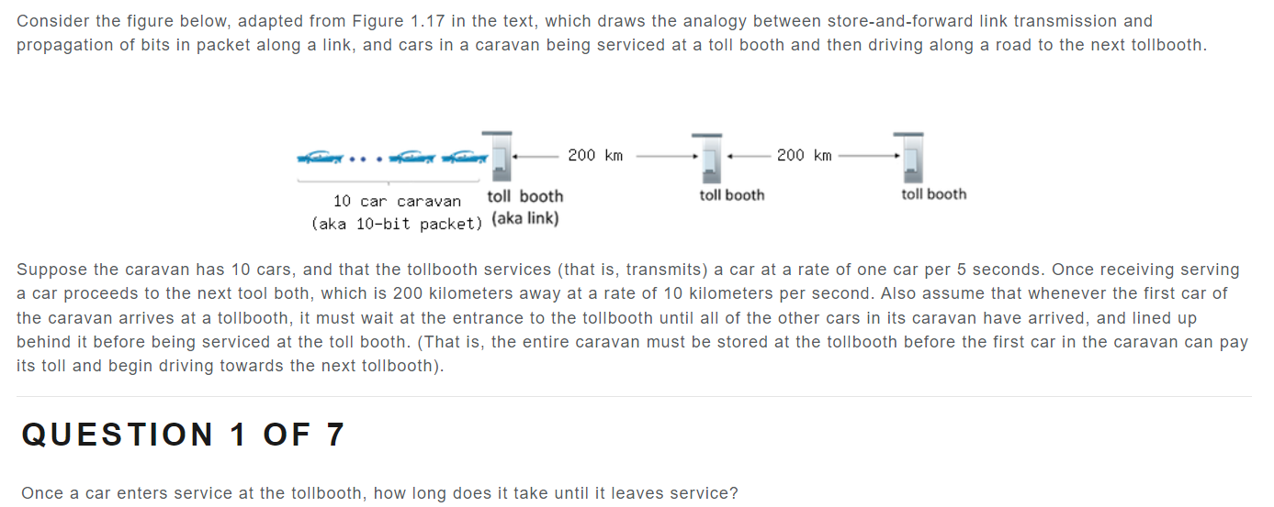

Answer: 5 seconds

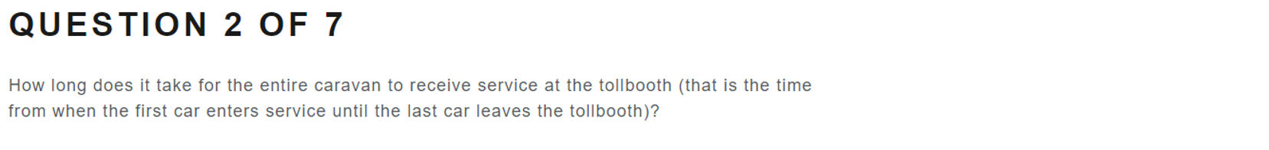

Answer: 50 seconds



Answer: 20 seconds



Answer:20 seconds



Answer: 65 sEconds

Answer: No

Answer: Yes (t=50s to t=70s)